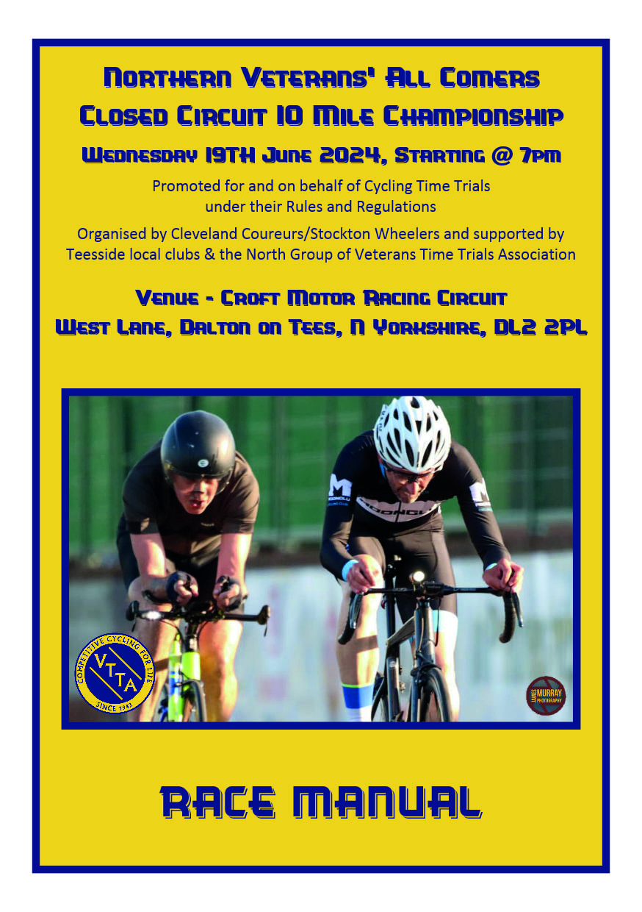**Welcome** to this, the fourth VTTA Northern Veterans' 10 Mile Closed Circuit “All Comers” Championship to be held at the at the Croft Motor Racing Circuit in North Yorkshire.

Please enjoy your visit to the North Yorkshire and to the Croft Motor Circuit

**Organiser details:**

Gavin Russell, 2 Antrim Ave, Fairfield, Stockton-on-Tees, TS19 7JF Tel:01642 654419

Email: gavin_russell@hotmail.co.uk

Paul Kitson, 6, Goldcrest Close, Ingleby Barwick, Stockton-on -Tees, TS17 0TE Tel. 07971 266153

Email: cycling@kitson49.plus.com

Any complaints regarding event, should be received by the organizers within 24hrs of the finish of event.

**IMPORTANT NOTICE: There is a motor car practice day earlier in the day. Please arrange to arrive after 5pm.**

**There is a “Come & Try It” club type event starting at 6:15pm. If there are more than 90 riders in the come & try it event, the additional riders will start after the last championship rider.**

**As an international motor racing circuit and in accordance with FIA rules and the circuits regulations, NO ANIMALS ARE ALLOWED INTO THE VENUE. With numerous notices displayed at the entrance to the circuit, the circuit security keep a close watch on this. With the circuit covered by a number of CCTV cameras, we have in the past experienced a number of incidents of visitors bring dogs onto the venue, SO PLEASE DO NOT BRING PETS WITH YOU.**

**Circuit details: T10C -** The course consists of the closed Croft motor racing circuit, which is just over 2 miles in length. Starting at the speed de-restriction line at the North end of the pit lane, riders will join the main circuit and complete 5 laps. On the 5th lap, riders, keeping left out of sharp corner, should enter the south end of pit lane, to finish at the chequered board, placed at the speed restriction line. (10 miles)

Riders must count their own laps or be aware of distance covered, to ensure they turn into the pit lane at the end of lap 5**. Riders who do not finish in pit lane will not receive a time.**

**Officials and timekeepers:** The volunteers, drawn from across the VTTA North Group and the Teesside district, are providing the support on this evening. to ensure your attendance and participation is made as enjoyable as possible:

**Event Parking:** On entering the driveway to the circuit. continue on main drive and turn left into car park area. It has been agreed that all the cars associated with our event will be parked in this location.

**Nominated Responsible Person on the Day:** Gavin Russell (Cleveland Coureurs CC)

**Results:** Paul Kitson (Stockton Wheelers CC)

**Sign-In & Numbers:** Donna Jarp & Colin Leckenby (Stockton Wheelers CC)

**Timekeepers:** David Oliver (Hartlepool CC), Colin Whitfield (Stockton Wheelers CC), Gavin Russell (Cleveland Coureurs), Paul Kitson (Stockton Wheelers CC) & Mike Penrice (VTTA Yorkshire Group)

**Number Catcher:** John Grant (Hartlepool CC) & Stuart Russell (Cleveland Coureurs CC)

**Hospitality:** Nuala Lewis & Wendy Nichol. Refreshments (Sandwich, cakes and biscuits) together with tea, coffee, chocolate and cold drinks will be provided free and available before, during and after the event. Any kind donation gratefully received.

**Start Steward:** Colin Lowe (Stockton Wheelers CC)

**VTTA NEC Representative:** Mike Penrice (VTTA Yorkshire Group)

**Eligible riders:** All riders, who start the event, regardless whether they are members of the VTTA or not, are eligible for the awards. All riders must be over 40 years of age on the day of the event.

**Awards:** All Medals have been provided by the VTTA National Executive Committee. There are 4 jerseys being presented this year.

Medals (gold, silver or bronze) will be presented to the first three in the following categories: Men (time trial machines), Women (time trial machines), Men (road bike machines) and Women (road bike machines). Winners will be declared on the result using the VTTA age handicap system. In addition, for the first time, VTTA Northern Closed circuit Championship Jerseys will be presented to the winners in each category.

**Sign-In & Race Numbers:** The sign-in and provision of numbers will take place in garage no 8**, (adjacent to control tower)** commencing at 5:15pm.

**Start Time:** The first rider will start circa 7:00pm, with the following riders starting at 30second intervals. The riders list identifies your actual start time. Riders must start with one foot on the ground, NO TRACK STANDS.

**Sign-Out & Race Numbers:** After the event, please sign-out. Failure to sign-out will result in a DNF being posted in the results. Numbers should be returned to the sign-on area.

**Warming Up prior to event:** Riders are welcome to warm up and familiarize themselves prior to their ride. This must be done prior to the start of the “associated “Come & Try It event which starts at 6:15pm. After the start of theis event, warming up should take place on the adjacent tarmac runway to the right of the main driveway, approx. 250 yds after entering the main circuit. No aircraft are scheduled to take off or land during the event. No warming up will be allowed after the start of the earlier event. If in doubt, please ask.

Toilets & Showers: Are situated opposite the control tower, in the single-story wooden building.

**Results:** The rider’s times will be displayed at the headquarters location (garage no 8) and will be published on CTT and VTTA websites and emailed to all riders.

**Presentation:** The presentation of the medals by the national VTTA representative, Mike Penrice, will be made as soon after the last rider has finished and all times have been displayed.

**Photographs:** An official photographer has agreed to attend the championship. James Murray of James Murray Photography, will be taking photographs during the event and will post them on his Facebook page.

**IMPORTANT INFORMATION: I**t is a CTT regulation that all riders must wear a helmet that meets recognized standards, whilst competing in time trials, whether on the open road or closed circuits.

It is also a CTT regulation that all riders start with a working front and rear light (affixed to the machine). There are a number of both front and rear lights available to borrow for the duration of the event, should you forget yours. Please enquire at the sign in table as to your requirements. Please can you return the lights, when signing out on completion of your ride.

**When you have completed your ride, please keep the pit lane clear of supporters and riders, as other competitors may be finishing extremely fast and require the pit lane to slow down.**

**2024 Teesside District Road Bike Specification:**

To compete in the 2024 road bike category in any Teesside District event, the following specification, which complies with the CTT regulations, (as amended at the 2022 national council meeting) is appropriate to the conditions of inclusion:

**The Rider:**

No time trial style pointy helmets (including Kask Bambino), or helmets with built in visors are to be worn.

Use of skinsuits is permitted

No riding with elbows or forearms on the handlebars. (Puppy Paws) If witnessed, the competitor may be disqualified.

**The Machine:**

The frame should be constructed in the traditional pattern, i.e. built around a main triangle. Multi geared bikes as well as fixed wheel machines are permitted. Trikes of similar construction are permitted in this category.

No time trial style or triathlon forward extension bars with or without elbow pads will be used.

Wheels should be of a spoked construction, with a minimum of 12 spokes and a maximum depth of 90mm.

Please apply the spirit of the road bike competition in your equipment choice. Non-compliance with any of the above will result in the competitor being excluded from the road bike category.

**First Rider to start at 7:00:30pm**

|  |  |  |  |  |  |  |
| --- | --- | --- | --- | --- | --- | --- |
| **Women’s Road Bike Category** | | | | | | |
| **No** | **Start Time** | **Name** | | **Club/Team/Association** | **Age** | **Age Adjustment** |
| 1 | 19:00:30 | Helen | Chalton | Manilla Cycling | 52 | 02:56 |
| 2 | 19:01:00 | Tracy | Henderson | Hetton Hawks CC | 48 | 02:43 |
| 3 | 19:01:30 | Deborah | Capewell | Team Ohten Aveas | 58 | 03:34 |
| 4 | 19:02:00 | Sarah | Minto | North Tyneside Riders CC | 42 | 02:33 |
| 5 | 19:02:30 | Yoko | Okada | Durham Triathlon Club | 41 | 02:32 |
| 6 | 19:03:00 | Gemma | Mitchell | Team Boompods | 44 | 02:36 |

|  |  |  |  |  |  |  |
| --- | --- | --- | --- | --- | --- | --- |
| **Women’s Time Trial Bike Category** | | | | | | |
| **No** | **Start Time** | **Name** | | **Club/Team/Association** | **Age** | **Age Adjustment** |
| 7 | 19:03:30 | Louise | Hamilton | Zurbaran Racing | 54 | 03:06 |
| 8 | 19:04:00 | Jo | Scott | Darlington CC | 60 | 03:53 |
| 9 | 19:04:30 | Angela | Hannon-Flaherty | Seacroft Whs | 55 | 03:12 |
| 10 | 19:05:00 | Sarah | Foulds | Team VC | 43 | 02:35 |
| 11 | 19:05:30 | Karen | Taylor | Springfield Financial Racing Team | 57 | 03:26 |

|  |  |  |  |  |  |  |  |  |  |  |  |  |
| --- | --- | --- | --- | --- | --- | --- | --- | --- | --- | --- | --- | --- |
| **Open Road Bike Category** | | | | | | | | | | | | |
| **No** | **Start Time** | | **Name** | | | | **Team/TeamlAssociation** | | **Age** | | **Age Adjustment** | |
| 12 | 19:06:00 | | Deborah | | Jefferies | | Manilla Cycling | | 43 | | 02:35 | |
| 13 | 19:06:30 | | Paul | | Roberts | | Hambleton RC | | 62 | | 02:05 | |
| 14 | 19:07:00 | | Clifford | | Featherstone | | Reifen Racing | | 71 | | 03:44 | |
| 15 | 19:07:30 | | Paul | | Felce | | Team VC | | 52 | | 00:49 | |
| 16 | 19:08:00 | | Robin | | Dale | | Darlington Tri Club | | 43 | | 00:08 | |
| 17 | 19:08:30 | | John | | Barnett | | Otley CC | | 69 | | 03:19 | |
| 18 | 19:09:00 | | John | | Leach | | Rossendale RC | | 79 | | 05:47 | |
| 19 | 19:09:30 | | Mark | | Fayers | | Richmond CC | | 62 | | 02:05 | |
| 20 | 19:10:00 | | Mike | | Chalton | | Manilla Cycling | | 53 | | 00:55 | |
| 21 | 19:10:30 | | Dave | | King | | VC Briganti | | 77 | | 05:12 | |
| 22 | 19:11:00 | | Richie | | Grant | | Hartlepool CC | | 58 | | 01:31 | |
| 23 | 19:11:30 | | Ian | | Gaskins | | Zurbaran Racing | | 49 | | 00:33 | |
| 24 | 19:12:00 | | Mike | | Jefferies | | AIMS Cycling | | 42 | | 00:05 | |
| 25 | 19:12:30 | | Mark | | Bailie | | Tyneside Vagabonds CC | | 45 | | 00:15 | |
| 26 | 19:13:00 | | Graeme | | Carter | | Stockton Wheelers CC | | 50 | | 00:38 | |
| 27 | 19:13:30 | | Steven | | Moody | | Teesdale CRC | | 43 | | 00:08 | |
| 28 | 19:14:00 | | Jez | | Willows | | Sherwood CC | | 59 | | 01:39 | |
| 29 | 19:14:30 | | Paul | | Daly | | Manilla Cycling | | 43 | | 00:08 | |
| 30 | 19:15:00 | | Andrew | | Donald | | AIMS Cycling | | 53 | | 00:55 | |
| 31 | 19:15:30 | | John | | Davidson | | Reifen Racing | | 61 | | 01:56 | |
| 32 | 19:16:00 | | Damien | | Riley | | Teesdale CRC | | 43 | | 00:08 | |
| 33 | 19:16:30 | | Phil | | Wright | | Hartlepool CC | | 69 | | 03:19 | |
| 34 | 19:17:00 | | Stuart | | Wearmouth | | Zurbaran Racing | | 47 | | 00:23 | |
| 35 | 19:17:30 | | Michael | | Vaiksaar | | Valley Striders Cycling Club | | 47 | | 00:23 | |
| 36 | 19:18:00 | | Russell | | Wright | | Manilla Cycling | | 40 | | 00:00 | |
| 37 | 19:18:30 | | Lee | | Ridden | | Reifen Racing | | 56 | | 01:16 | |
| **Open Time Trial Bike Category** | | | | | | | | | | | | | |
| **No** | | **Start Time** | | **Name** | | | | **Club/Team/Association** | | **Age** | | **Age Adjustment** | |
| 38 | | 19:19:00 | | John | | Main | | Cleveland Wheelers CC | | 67 | | 02:56 | |
| 39 | | 19:19:30 | | Paul | | Wynne | | Kinross CC | | 64 | | 02:24 | |
| 40 | | 19:20:00 | | Dougan | | Collins | | Zurbaran Racing | | 59 | | 01:39 | |
| 41 | | 19:20:30 | | Paul | | Dawson | | VTTA (North) | | 63 | | 02:14 | |
| 42 | | 19:21:00 | | Doug | | Harris | | Cleveland Wheelers CC | | 67 | | 02:56 | |
| 43 | | 19:21:30 | | Darren | | Chapman | | Darlington Cycling Club | | 60 | | 01:47 | |
| 44 | | 19:22:00 | | Drew | | Donaldson | | Glasgow United CC | | 65 | | 02:34 | |
| 45 | | 19:22:30 | | Roy | | Oakes | | Team Ohten Aveas | | 79 | | 05:47 | |
| 46 | | 19:23:00 | | Bryan | | Harding | | Durham Triathlon Club | | 65 | | 02:34 | |
| 47 | | 19:23:30 | | Andrew | | Harland | | Darlington Tri Club | | 56 | | 01:16 | |
| 48 | | 19:24:00 | | Andy | | Biggs | | Durham Triathlon Club | | 56 | | 01:16 | |
| 49 | | 19:24:30 | | Carl | | Taylor | | Cleveland Wheelers CC | | 59 | | 01:39 | |
| 50 | | 19:25:00 | | Gordon | | Johnson | | Clifton CC York | | 59 | | 01:39 | |
| 51 | | 19:25:30 | | Brad | | Armstrong | | Velo Club Rutland | | 70 | | 03:31 | |
| 52 | | 19:26:00 | | Ian | | Hutchinson | | Cleveland Wheelers CC | | 68 | | 03:07 | |
| 53 | | 19:26:30 | | Andy | | Delaney | | Northumbria Police C.C. | | 55 | | 01:09 | |
| 54 | | 19:27:00 | | Duncan | | Smart | | Scarborough Paragon CC | | 55 | | 01:19 | |
| 55 | | 19:27:30 | | David | | Hird | | Hambleton RC | | 48 | | 00:28 | |
| 56 | | 19:28:00 | | Oliver | | Clissold | | Cleveland Wheelers CC | | 62 | | 02:05 | |
| 57 | | 19:28:30 | | Ray | | Hall | | Protech Velo | | 63 | | 02:14 | |
| 58 | | 19:29:00 | | Mick | | Flaherty | | Seacroft Whs | | 62 | | 02:05 | |
| 59 | | 19:29:30 | | Terry | | Parvin | | Ferryhill Whs | | 64 | | 02:24 | |
| 60 | | 19:30:00 | | Lee | | Morley | | Hartlepool CC | | 53 | | 00:55 | |
| 61 | | 19:30:30 | | Simon | | Emsley | | Team VC | | 52 | | 00:49 | |
| 62 | | 19:31:00 | | Wayne | | Coates | | Team Bottrill | | 65 | | 02:34 | |
| 63 | | 19:31:30 | | Stephen | | Adamson | | Fietsen Tempo | | 51 | | 00:43 | |
| 64 | | 19:32:00 | | Shaun | | Wakes | | Ferryhill Whs | | 56 | | 01:18 | |
| 65 | | 19:32:30 | | Adrian | | Dent | | Team Ohten Aveas | | 63 | | 02:14 | |
| 66 | | 19:33:00 | | Jonathan | | Robinson | | Army Cycling | | 54 | | 01:02 | |
| 67 | | 19:33:30 | | Simon | | Horsley | | Legato Racing Team (LRT) | | 59 | | 01:39 | |
| 68 | | 19:34:00 | | Russ | | Richardson | | Zurbaran Racing | | 67 | | 02:56 | |
| 69 | | 19:34:30 | | Darren | | Robson | | Muckle Cycle Club | | 52 | | 00:49 | |
| 70 | | 19:35:00 | | Matt | | Hill | | Zurbaran Racing | | 63 | | 02:14 | |
| 71 | | 19:35:30 | | Allistair | | Moffat | | Velo Club Cumbria | | 41 | | 00:02 | |
| 72 | | 19:36:00 | | Philip | | Kennell | | GS Metro | | 57 | | 01:23 | |
| 73 | | 19:36:30 | | Kris | | Whitelaw | | Vector Racing | | 41 | | 00:02 | |
| 74 | | 19:37:00 | | Marcel | | Schubert | | Zurbaran Racing | | 42 | | 00:05 | |
| 75 | | 19:37:30 | | Richard | | Oakes | | Team Ohten Aveas | | 55 | | 01:09 | |

